Co-facilitators

What to Expect

This sibling retreat is a weekend event for transition age students with disabilities and their siblings. A variety of topics about transition will be presented. Young adults and their siblings will enjoy recreational and leisure activities. There will also be opportunities to learn from one another, share experiences and gain support.

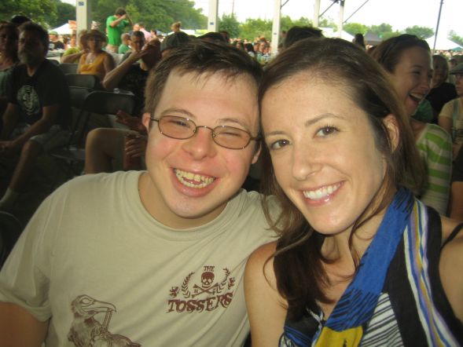
“Siblings will be in the lives of family members with disabilities longer than anyone. Brothers and sisters will typically be there after parents are gone and special education services are a distant memory. Theirs is a relationship that can easily exceed 65 years. When provided with support and information, these brothers and sisters can help their siblings with disabilities live dignified lives from childhood to their senior years.” –National Sibling Leadership Network

Sarah Hall, Ph.D. is an Assistant Professor in the Department of Inclusive Services and Exceptional Learners at the Columbus Center of Ashland University. She teaches graduate courses in special education, communication and collaboration, transition, and behavior management.
Tom Fish, PhD, LISW is the Director of Social Work and Family Support Services at The Ohio State University Nisonger Center on Disabilities. He directs projects dealing with autism, community inclusion, adult literacy, and community service. He is a founding member of the National Sibling Leadership Network.

Sponsored By:
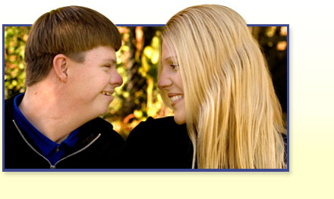
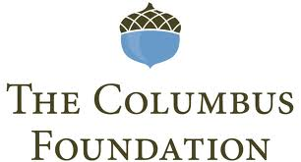

A Weekend Retreat about Transition
SIBS Looking Forward

When and Where?
The retreat will be held on Friday April 20 until Sunday April 22 at Camp Wilson in Bellefontaine. Transportation from Columbus to the camp will be provided by the Franklin County Board of DD. Transportation will leave from Dublin Scioto High School at 4pm on Friday. Families are responsible for picking up their children from the camp at noon on Sunday.

Who can participate?
Students with disabilities who are between the ages of 17 and 22 are eligible. Their accompanying sibling must be between the ages of 16 and 25.

Cost?
The retreat is FREE! A contribution to Ohio SIBS would be greatly appreciated.

Why come?
This retreat will promote a better appreciation on how the brothers and sisters of students with disabilities can help them become more independent, engaged in the community, and ready for employment. Transition is a critical time for students with disabilities and this retreat offers a unique chance to highlight the importance of the sibling relationship. Monthly information and resources will follow after the retreat to help support both siblings throughout the year. Topics to be covered: transition, community living, employment, decision-making, and advocacy.

Connecting with Ohio SIBS
This weekend is a collaborative effort of Ohio SIBS, The Columbus Foundation, and the OSU Nisonger Center. It is the mission of Ohio SIBS to provide advocacy, education, leadership and supports that promote enhanced quality of life, improved public policy, and increased supports for siblings of people with developmental disabilities and their families.

Application of Interest
For more information please fill out the following information and return to Dr.Tom Fish at: McCampbell Hall, 1581 Dodd Drive, Columbus, OH, 43210 or e-mail him at fish.1@osu.edu.

Name of Student:

Student Age:

Name of Parent(s):

Name of Sibling:

Sibling Age:

Address:

E-mail:

Parent Phone Number:

